Adithya.J

230701013 CSE A

EXP NO:7 IPC USING SHARED MEMORY

PROGRAM

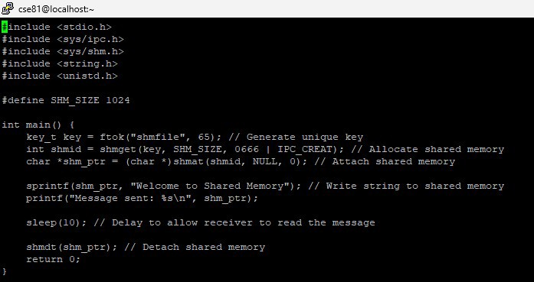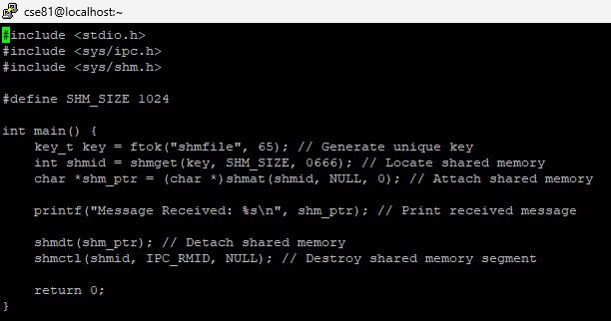

OUTPUT

